1. Individual contribution, self-learning and project management
1.1 Individual contribution to the project
My main responsibility in the Job Recruitment System (JRS) project was the HR-facing notification and account area. I was responsible for defining the scope of this area, preparing the use cases, producing the high-fidelity interface design, modelling its database relationships, and converting the approved design into static HTML pages. The work was completed in several iterations because the first notification concept overlapped with the HR Applications and Interview modules. I compared my design with the application workflow produced by another team member and removed functions that were already handled elsewhere, including candidate status changes, interview scheduling, interviewer reminders, feedback reminders, offer approval, and contract creation. This scope review was important because it prevented duplicated functionality and made the final system architecture easier to understand.
The final notification area contains three connected functions. The Notification Center provides internal system messages for HR, such as a new application being received or a candidate status being updated. The Email Templates page allows HR to manage reusable candidate-facing messages, including Interview Invite, Offer Letter, Accepted, Rejected, and In Progress templates. The Notification Log records successfully sent candidate emails and stores the candidate, position, trigger event, template, source module, recipient email, and sent time. I also added the HR account interface, and this work includes the avatar drop-down menu, My Profile page, and Edit Profile page. The profile interface distinguishes editable personal data from system-controlled fields such as employee ID, role, department, work email, and account status.
My contribution directly supports the results described in the group section. For the functional requirements and system specification result, I prepared and revised the use case stories for the Notification Center, template management, notification history, profile viewing, profile editing, and logout. For the system-wide Figma result, I designed all screens assigned to the notification and HR profile area and made their visual style consistent with the HR dashboard and application pages. For the relational database result, I produced the notification module ER diagram, including HR_USER, SYSTEM_NOTIFICATION, EMAIL_TEMPLATE, NOTIFICATION_LOG, NOTIFICATION_ATTACHMENT, APPLICATION, CANDIDATE, and JOB_POSITION. I defined the primary keys, foreign keys, and one-to-many relationships, then reorganized the diagram so that the connectors were readable and did not overlap. For the static front-end result, I developed five HTML pages that reproduce the approved design: Notification Center, Email Templates, Notification Log, My Profile, and Edit Profile.
1.2 Estimated contribution to project results
The percentages below are my best estimate. They represent my contribution to each group result rather than a percentage of the whole project effort. I completed the notification and HR profile deliverables myself, while the overall JRS contains several other modules completed by other team members.

Result / deliverable | My contribution | Estimated share
Functional requirements and use case stories | Defined and revised the Notification Center, Email Templates, Notification Log, HR Profile, Edit Profile and Logout use cases. | 100% of assigned module; ~20% of group FRS
High-fidelity Figma prototype | Designed and refined every notification and HR profile screen, including the shared navigation, avatar menu and states. | 100% of assigned screens; ~20% overall
ER modelling and database design | Created the notification ER diagram, PK/FK structure, cardinalities and cross-module links to Application, Candidate and Job Position. | 100% of module ERD; ~15% overall
Static HTML front-end | Implemented five HTML/CSS pages matching the approved design and prepared screenshots as evidence. | 100% of assigned pages; ~20% overall
Cross-module integration review | Removed duplicated functions and aligned terminology and boundaries with the HR Applications workflow. | ~20% of integration review

1.3 Contribution to team integration and support
In addition to my assigned deliverables, I helped the team by checking cross-module consistency. The most important example was the boundary between Notifications and Applications because in the earlier drafts included automatic notification triggers, interview reminders, feedback reminders, and pending feedback management. After comparing these functions with the HR Applications workflow, I identified that they either duplicated another member's work or represented direct communication that did not need a separate system page. I therefore simplified the module and kept only system notifications, email templates, sent-message history, and HR profile management. I also standardized labels such as Candidate, Application, Trigger Event, Template Used, Source Module, and Sent Time so that the database model, use case stories, Figma screens, and HTML pages use the same terminology. This review helped reduce integration problems before coding.
1.4 Self-directed learning
My self-directed learning focused on commercial HR workflows, system notification design, Figma, and HTML/CSS. To define the module correctly, I studied how recruitment systems divide application review, status updates, interviews, offers, and candidate communication across different modules. This helped me separate Applications and Interviews functions from Notification, so my design informs HR about important events, links to the relevant application, manages candidate email templates, and records sent messages. I also examined the structure of system notifications, including type, title, message, source module, related application, recipient, read status, and timestamp, while email logs require a trigger event, template, recipient email, sent time, delivery status, and attachment reference. These findings guided the Notification Center, Email Templates, Notification Log, profile pages, and ER model.
For Part B, I will learn API and database integration, authentication, role-based access control, SQL, validation, data security, and cross-module testing, so the static prototype can load real records, update read status, manage templates, and display notification history.
1.5 Project management, meetings and teamwork
Project management tools were important because the team was working on different modules at the same time. The Gantt chart and work breakdown structure helped divide the project into requirements, modelling, interface design, implementation, testing, and documentation activities. Figma acted as the shared source of truth for interface decisions, which allowed me to compare my screens with the HR dashboard and Applications pages before finalizing them. GitHub provides a controlled location for source files and will support version history and integration during Part B. Meeting minutes and shared progress updates recorded decisions, assigned actions, and changes to module boundaries. These tools reduced the risk of two members developing the same feature and gave the team time to review work before submission.
During the interim phase, the team held weekly discussions and met the supervisor about once every two weeks. I attended regularly, shared ideas, explained the notification workflow, identified duplicated functions, and presented updated interface drafts, these discussions helped me clarify my module boundaries and improve the design.
My cooperation with team members was positive. After reviewing the completed HR Applications screens, I removed overlapping functions from my Notification module and improved the connection between both areas and I also completed my main tasks before the internal deadline, which allowed time for revision. Based on feedback, I removed unnecessary reminders, added the HR profile section, aligned the interface style, and improved the ER diagram routing. Overall, the use cases, Figma screens, ER model, and HTML pages now follow a consistent scope and are ready for Part B integration.

2. Evidence of individual technical work
The following figures provide evidence of the database modelling and static front-end implementation completed for my assigned module. The ER diagram shows how notification data relates to the wider JRS, while the HTML screenshots demonstrate the working page layouts prepared from the approved interface design.
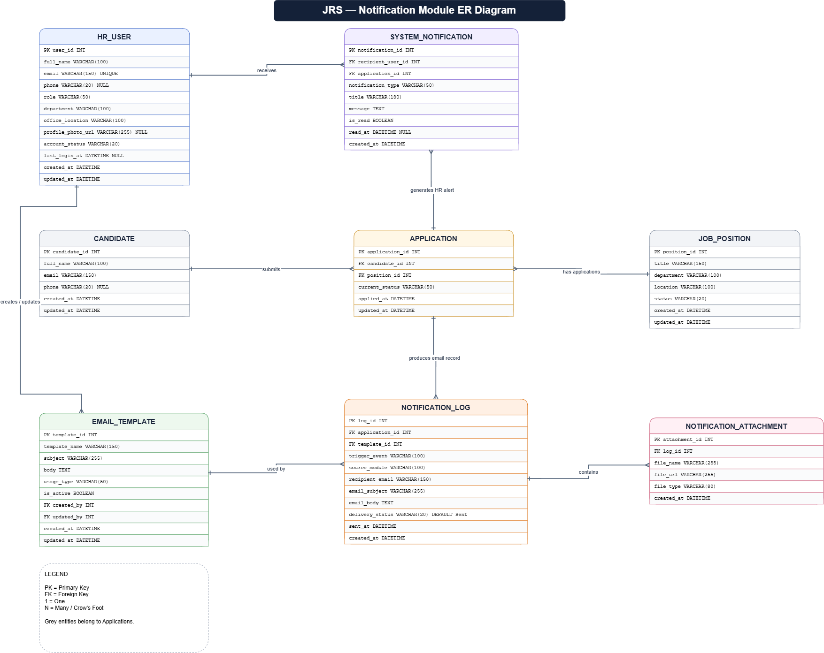
Figure 4: Notification module ER diagram showing HR profile, system notification, template, application, log and attachment relationships.

3. Static HTML front-end implementation
I created the following HTML and CSS pages as a static implementation of the approved Figma design. Each page uses the same dark sidebar, top navigation, card layout, colours, spacing and HR account area so that the module is visually consistent with the rest of the system.
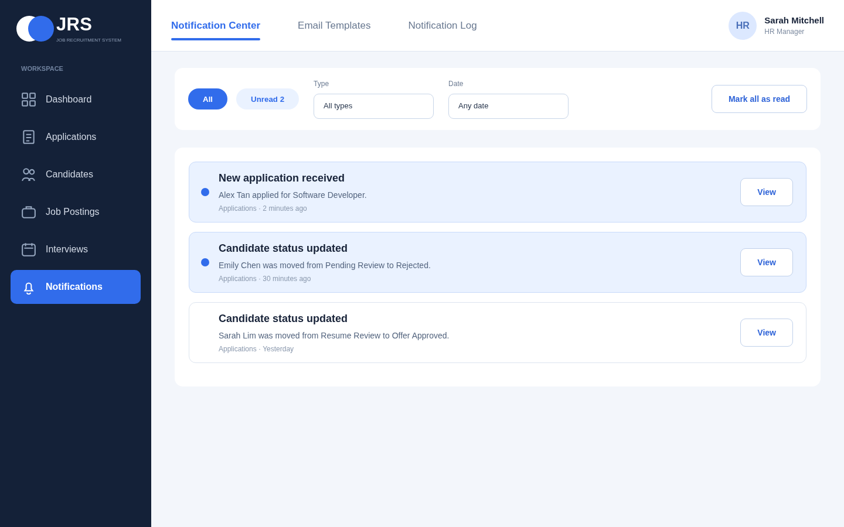
Figure 5: Notification Center HTML page showing unread system events for new applications and candidate status updates.
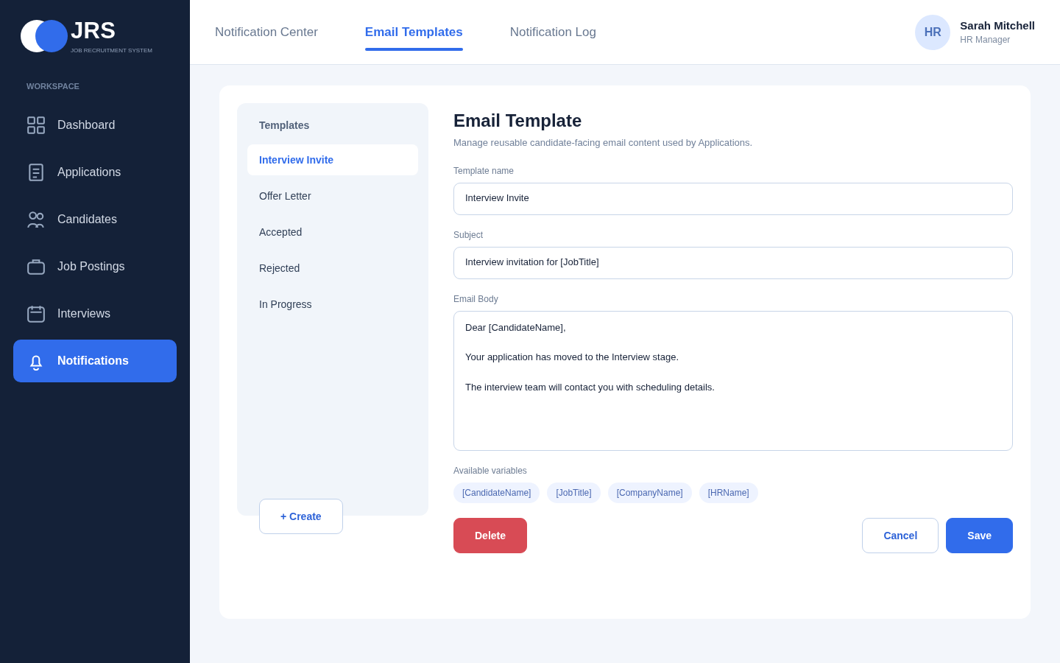
Figure 6: Email Templates HTML page for creating and maintaining reusable candidate-facing messages.

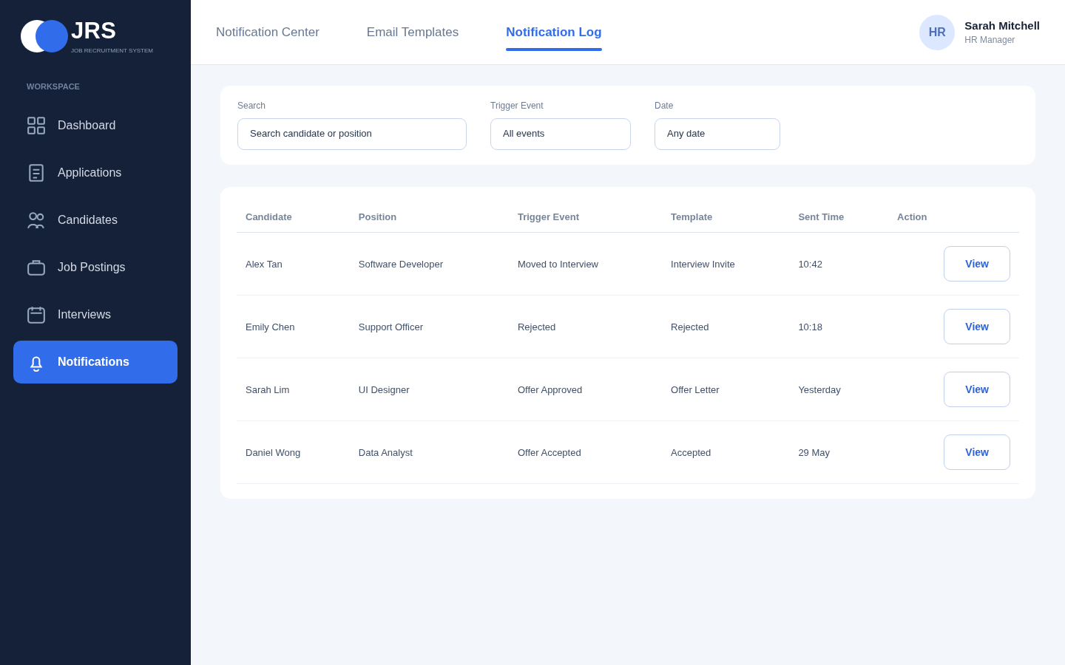
Figure 7: Notification Log HTML page showing successful candidate email records and trigger events.
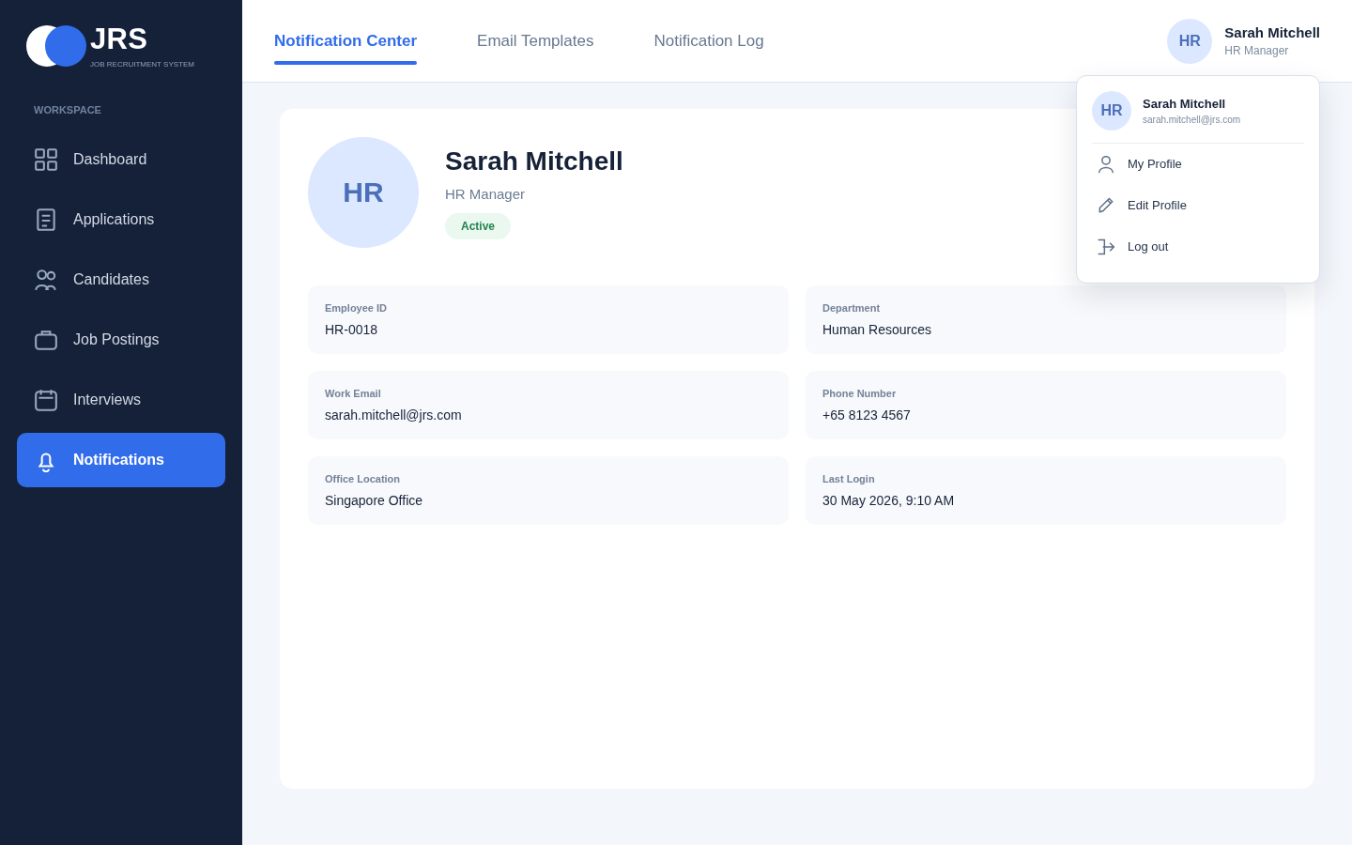
Figure 8: HR My Profile HTML page with the avatar drop-down menu and account details.

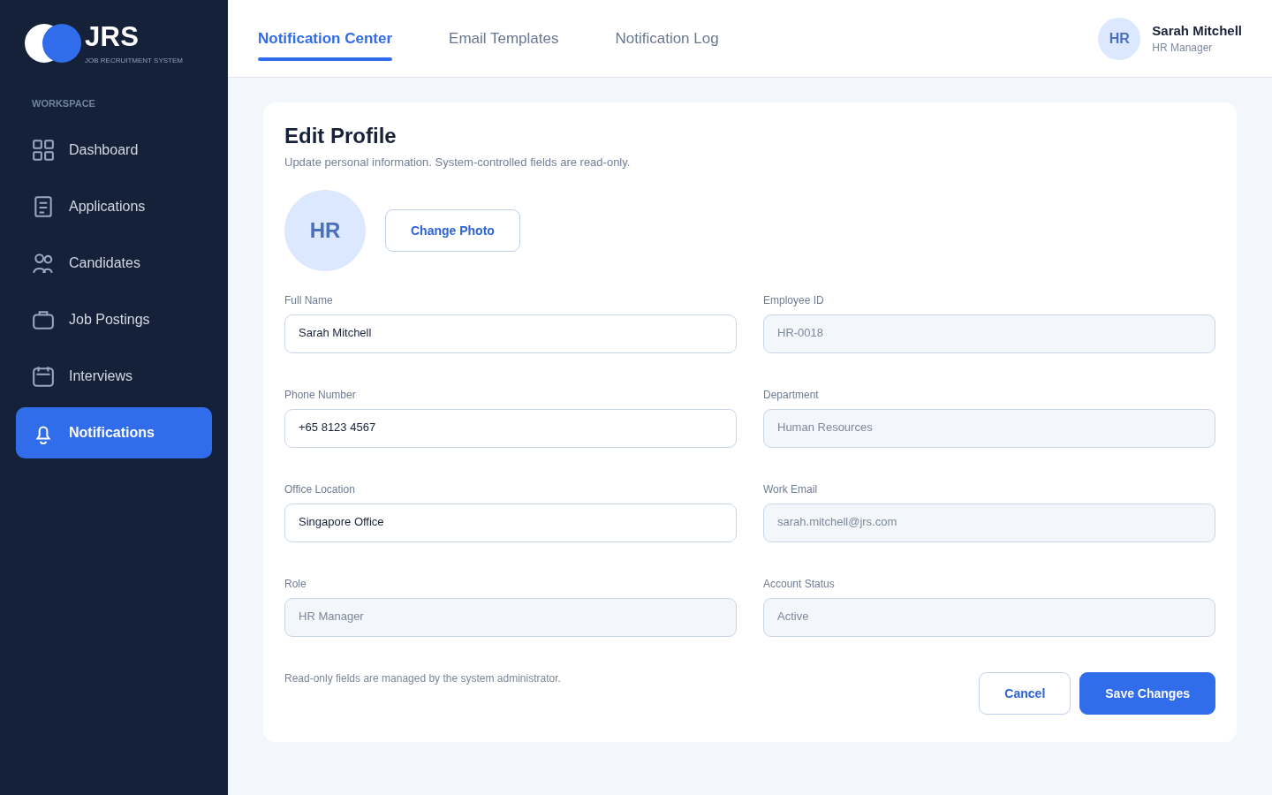
Figure 9: Edit Profile HTML page separating editable personal information from system-controlled fields.

